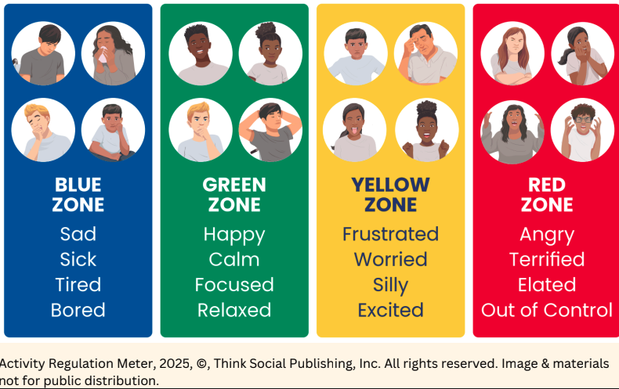
How do you feel about...





Label

Label

Label

Label





Label

Label

Label

Label

Label

Label

Label

Label

Label

Label

Label

Label





Label

Label

Label





